11. Applying databases normalization technique to eliminate redundancy and improve data integrity in workbench query.

create database colleges;
use colleges;
- Create Unnormlize Table:
CREATE TABLE students_courses(
student_id INT,
student_name VARCHAR(50),
course_id INT,
course_name VARCHAR(50),
PRIMARY KEY (student_id,course_id)
);
INSERT INTO students_courses VALUES
(1,'Neha', 201, 'Math'),
(2,'Anushka', 202, 'Physics'),
(3, 'Sakshi', 203, 'Math');
SELECT*FROM students_courses;
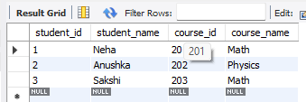

2. (Normalize to 1NF,2NF, and 3NF)
Create Students Table (Remove redundant student info)

CREATE TABLE students(
student_id INT PRIMARY KEY,
student_name VARCHAR(50)
);
INSERT INTO students(student_id,student_name)
SELECT DISTINCT student_id,student_name
FROM students_courses;
SELECT*FROM students;

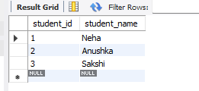

Create Course Table (Remove redundant course info)
CREATE TABLE courses(
course_id INT PRIMARY KEY,
course_name VARCHAR(50)
);
INSERT INTO courses(course_id,course_name)
SELECT DISTINCT course_id,course_name
FROM students_courses;
SELECT*FROM students;
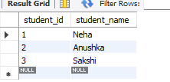
Create Enrollments Tables (Mapping table between students and courses)
CREATE TABLE enrollements(
student_id INT,
course_id INT,
PRIMARY KEY (student_id,course_id),
FOREIGN KEY(student_id)REFERENCES students(student_id),
FOREIGN KEY (course_id)REFERENCES courses(course_id)
);
INSERT INTO enrollements(student_id,course_id)
SELECT student_id,course_id
FROM students_courses;
SELECT*FROM enrollments;

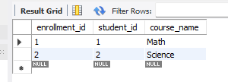

3. Test the normalized structure. (At a time execute this querry)
SELECT*FROM students;
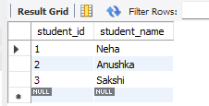
SELECT*FROM courses;

SELECT*FROM enrollements;
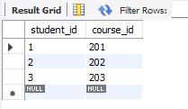
SELECT c.course_name
FROM students s
JOIN enrollements e ON s.student_id=e.student_id
JOIN courses c ON e.course_id=c.course_id
WHERE s.student_name='Neha';



